Nebula Server & Nebula Studio
部署方式：单机部署
机器配置：4c16g
系统：centos7
部署版本：
Nebula Server：3.2.0
Nebula Studio：3.4.1

JavaClient：
部署方式：单机部署
CPU:Core™ i7
内存：16G
系统：win10

- 依赖
SpringBoot：2.7.2
Nebula Client：3.0.0

- Nebula配置
maxConnsSize：200

测试
- 测试接口
在SpringBoot应用中提供一个Controller，Controller中主要拼接一些随机值，然后进行Insert

- 测试工具
Jmeter：5.4.3
线程数量：100

结果
- Jmeter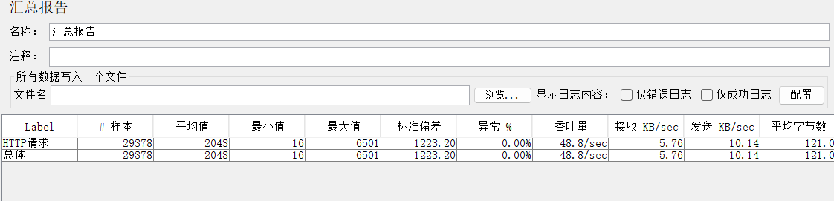

- CPU
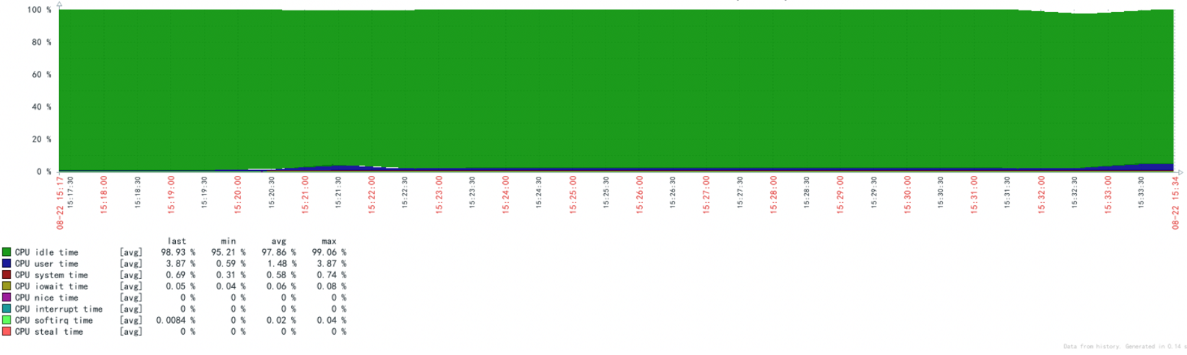
- 内存
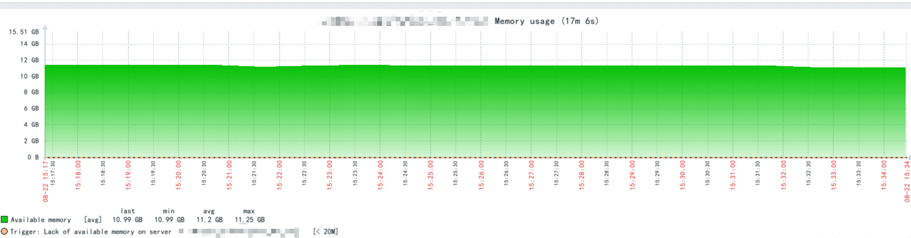
- 磁盘
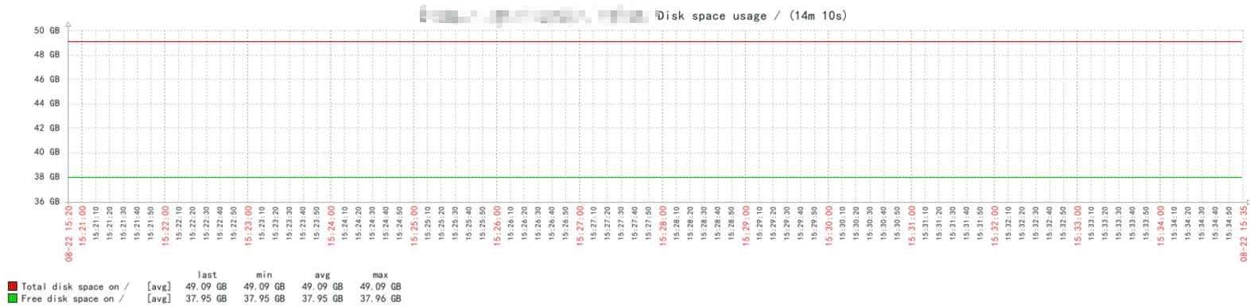

控制台输出
压测期间，输入的耗时日志如下，耗时的地方都是在session.execute

StopWatch '': running time = 5 s
---------------------------------------------
s % Task name
---------------------------------------------
000000000 00% 随机字符
000000000 00% 构建nGQL
000000005 100% Nebula Execute

大于5秒insert vertex ChangeLog(op_user_no,create_time,stage,op_content,pid,op_type,business_id,op_content_text) values 457042:(114760136,datetime('2022-07-25 06:55:57'),'o_customer','寸讹踏亥犹零杠勉跋仟',4000180039416,67,'1527569233605550711','寸讹踏亥犹零杠勉跋仟');

StopWatch '': running time = 5 s
---------------------------------------------
s % Task name
---------------------------------------------
000000000 00% 随机字符
000000000 00% 构建nGQL
000000005 100% Nebula Execute

大于5秒insert vertex ChangeLog(op_user_no,create_time,stage,op_content,pid,op_type,business_id,op_content_text) values 457041:(114481652,datetime('2022-01-05 08:23:41'),'o_contacts','恶捍缓殉诗铰昂抗肖泥',4000180039416,66,'1527569233605550710','恶捍缓殉诗铰昂抗肖泥');

StopWatch '': running time = 5 s
---------------------------------------------
s % Task name
---------------------------------------------
000000000 00% 随机字符
000000000 00% 构建nGQL
000000005 100% Nebula Execute

大于5秒insert vertex ChangeLog(op_user_no,create_time,stage,op_content,pid,op_type,business_id,op_content_text) values 457040:(114760131,datetime('2022-08-01 09:06:01'),'o_clue','库铱腕玲柄讥再熙悼甭',4000180039416,65,'1527569233605550709','库铱腕玲柄讥再熙悼甭');

StopWatch '': running time = 5 s
---------------------------------------------
s % Task name
---------------------------------------------
000000000 00% 随机字符
000000000 00% 构建nGQL
000000005 100% Nebula Execute

大于5秒insert vertex ChangeLog(op_user_no,create_time,stage,op_content,pid,op_type,business_id,op_content_text) values 457039:(114760136,datetime('2022-05-08 07:23:14'),'o_order','养晰沪挑笛雀靠硝塑见',4000180039416,64,'1527569233605550708','养晰沪挑笛雀靠硝塑见');

StopWatch '': running time = 5 s
---------------------------------------------
s % Task name
---------------------------------------------
000000000 00% 随机字符
000000000 00% 构建nGQL
000000005 100% Nebula Execute

大于5秒insert vertex ChangeLog(op_user_no,create_time,stage,op_content,pid,op_type,business_id,op_content_text) values 457038:(114481652,datetime('2022-05-09 18:44:11'),'o_niche','柠师裕袄银井食睹蚜嚷',4000180039416,63,'1527569233605550707','柠师裕袄银井食睹蚜嚷');

StopWatch '': running time = 5 s
---------------------------------------------
s % Task name
---------------------------------------------
000000000 00% 随机字符
000000000 00% 构建nGQL
000000005 100% Nebula Execute

大于5秒insert vertex ChangeLog(op_user_no,create_time,stage,op_content,pid,op_type,business_id,op_content_text) values 457037:(114760131,datetime('2022-08-17 01:37:53'),'o_customer','两败醒瘩硒袒肾鹊匝肄',4000180039416,62,'1527569233605550706','两败醒瘩硒袒肾鹊匝肄');

StopWatch '': running time = 6 s
---------------------------------------------
s % Task name
---------------------------------------------
000000000 00% 随机字符
000000000 00% 构建nGQL
000000006 100% Nebula Execute

大于5秒insert vertex ChangeLog(op_user_no,create_time,stage,op_content,pid,op_type,business_id,op_content_text) values 457036:(114760136,datetime('2022-05-15 05:43:57'),'o_contacts','郎纪墓戳螟开良缔对披',4000180039416,61,'1527569233605550705','郎纪墓戳螟开良缔对披');

StopWatch '': running time = 6 s
---------------------------------------------
s % Task name
---------------------------------------------
000000000 00% 随机字符
000000000 00% 构建nGQL
000000006 100% Nebula Execute

大于5秒insert vertex ChangeLog(op_user_no,create_time,stage,op_content,pid,op_type,business_id,op_content_text) values 457035:(114481652,datetime('2022-01-14 13:33:44'),'o_clue','冬稍薄菠物峭崇柜税韵',4000180039416,60,'1527569233605550704','冬稍薄菠物峭崇柜税韵');

StopWatch '': running time = 6 s
---------------------------------------------
s % Task name
---------------------------------------------
000000000 00% 随机字符
000000000 00% 构建nGQL
000000006 100% Nebula Execute

大于5秒insert vertex ChangeLog(op_user_no,create_time,stage,op_content,pid,op_type,business_id,op_content_text) values 457034:(114760131,datetime('2022-01-15 19:46:50'),'o_order','铰刺辫蛔玉蛋原厨下察',4000180039416,59,'1527569233605550703','铰刺辫蛔玉蛋原厨下察');

StopWatch '': running time = 6 s
---------------------------------------------
s % Task name
---------------------------------------------
000000000 00% 随机字符
000000000 00% 构建nGQL
000000006 100% Nebula Execute

大于5秒insert vertex ChangeLog(op_user_no,create_time,stage,op_content,pid,op_type,business_id,op_content_text) values 457033:(114760136,datetime('2022-03-01 23:03:11'),'o_niche','如慢江辐室浩嫩章斌鞍',4000180039416,58,'1527569233605550702','如慢江辐室浩嫩章斌鞍');

StopWatch '': running time = 3 s
---------------------------------------------
s % Task name
---------------------------------------------
000000000 00% 随机字符
000000000 00% 构建nGQL
000000003 100% Nebula Execute

StopWatch '': running time = 3 s
---------------------------------------------
s % Task name
---------------------------------------------
000000000 00% 随机字符
000000000 00% 构建nGQL
000000003 100% Nebula Execute

StopWatch '': running time = 3 s
---------------------------------------------
s % Task name
---------------------------------------------
000000000 00% 随机字符
000000000 00% 构建nGQL
000000003 100% Nebula Execute

StopWatch '': running time = 3 s
---------------------------------------------
s % Task name
---------------------------------------------
000000000 00% 随机字符
000000000 00% 构建nGQL
000000003 100% Nebula Execute

StopWatch '': running time = 3 s
---------------------------------------------
s % Task name
---------------------------------------------
000000000 00% 随机字符
000000000 00% 构建nGQL
000000003 100% Nebula Execute

StopWatch '': running time = 3 s
---------------------------------------------
s % Task name
---------------------------------------------
000000000 00% 随机字符
000000000 00% 构建nGQL
000000003 100% Nebula Execute

